Kohli Decompositions of Gross and Net Real Income Growth for Canada

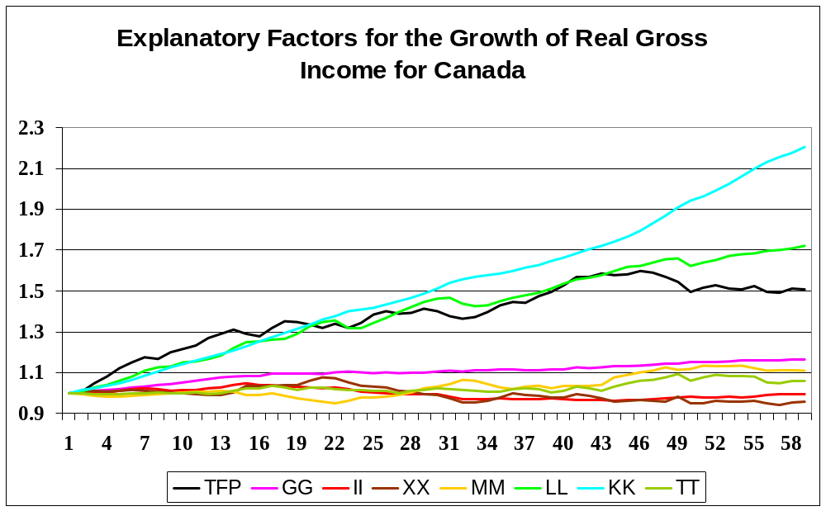

The above factors (excluding TT which is the combined effect of XX and MM) when multiplied together will give us real gross income generated by the production sector for Canada. You should reproduce this Chart for your country when you give your talk.

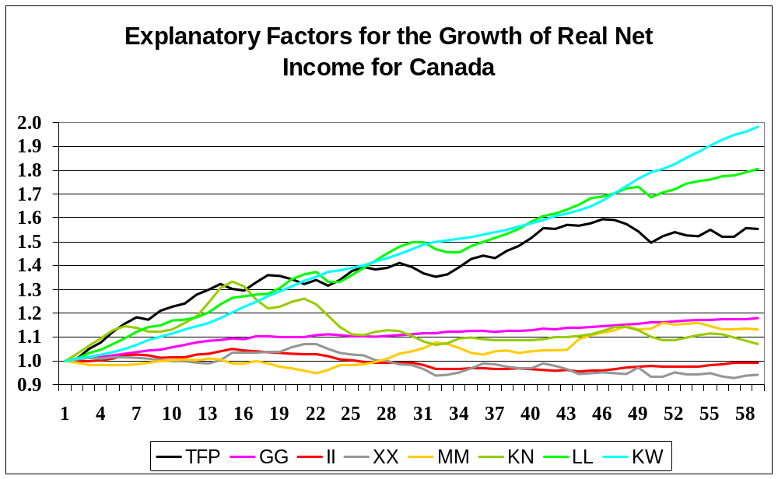

The above cumulated growth factors equal real net income generated by the production sector. The new growth factor in this model is KN, the net effect of changes in the real price of the beginning and end of period capital stocks for the economy. It can be seen that this growth factor was quite large for the beginning of our sample period. It may be large for your country as well at times. But overall, the important growth factors are growth in the waiting services of capital, KW, the growth in labour services, LL, and TFP growth. Note that the level of TFP reached its maximum for Canada in 2005 (Observation 46) and has not hit this level for the remainder of the sample period. The II factor is the next largest growth factor explaining the growth in real income. This is because the price of government services is largely the price of government labour and government wage increases have tended to be higher than the increases in consumer prices. This leads to an overall growth in real income. Changes in the terms of trade can be important for short periods of time. Again, you should reproduce this Chart for your country when you give your talk.

